COMMUNICATIONS COMMITTEE MEETING AGENDA
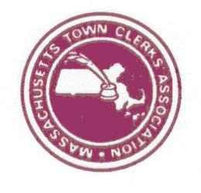
Wed, June 12th – 1:00 PM
Plymouth Conference

- Committee Roles & Responsibilities – FY20 listing
  - E-Board Approval
  - FY20 Listings
  - Time sensitive reminders:
    - Membership Benefits – FY flip – Nancy & Kelly
    - Welcome Correspondence – email to new members / Lists to AP & OPCF - Lynn
    - Online Welcome Packet Coordinator – annual updates to welcome packet - Andy
- Review of documents / approaches for communication committee responsibilities
- Review of New Clerk / Welcome Email - Lynn
- Review of New Fiscal Year Association dues - Lynn
- Review of MTCA Email Group Etiquette Document - Danielle
- Membership Dues & Benefits Communications - Danielle
- Website
  - New Pages – Scholarships & Conferences
  - Website Content Coordinators – Training
  - Regional Association Webpages
- Communication with members
    - WEBSITE: User Names / Where to find: surveys / samples / mentoring documents
    - EMAIL: Etiquette
    - CONFERENCES: Add staff to Membership Dues Forms / credit for attendance
- Next Meeting

