COMMUNICATIONS COMMITTEE MEETING AGENDA
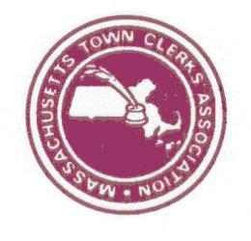
February 26, 2019
2 PM – PHONE MEETING

- Committee Membership
- Updates / Committee Roles
  - Public Recorder & Website Vendor Sponsorships – Nancy
  - Membership Benefits
    - Email – Nancy
    - Website – Kelly
  - Website - Kelly / Andy
- Review of documents / approaches for communication committee responsibilities
  - MTCA Email Group Etiquette Document - Danielle
  - Membership Dues & Benefits Communications – Lynn
- New Business
  - Regional Association Webpages
  - E-Board communication request
    - WEBSITE: User Names / Where to find: surveys / samples / mentoring documents
    - EMAIL: Etiquette
    - CONFERENCES: Add staff to Membership Dues Forms / credit for attendance
- Next Meeting

