COMMUNICATIONS COMMITTEE MEETING AGENDA
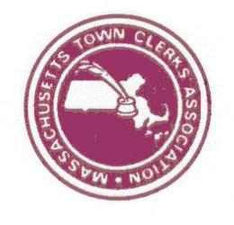
January 9, 2018
11 AM – PHONE MEETING

- Public Recorder
  - Website – page set up (index, new information, sponsors information)
  - Advertising Fees (see attached information from last year)
- Membership Benefits Updates
  - Email – Nancy Burnham
  - Website – Kelly
  - City Memberships / Pending & Conference – Danielle & Lynn
- Website Updates - Kelly & Amy
- Appointments / E- Board Directory
- Pages to maintained by others:
    - MTCA committee pages - Marie
      - Bylaw Review
      - Communications Committee
      - Legislative Committee
      - Mentoring Committee
      - Task Force Advisory
  - E-Board
  - CMMC
  - Scholarships
  - Membership
  - Public Recorder
- Next Meeting

